Lab 2 Report
The purpose of this lab is to solidify you to the usage of some important lab equipments. The lab also offers two circuit to improve your understanding about using voltage source as a current source. This lab will allow you to learn about how to use a Lab Bench Power Supply as both voltage and current source, a breadboard, a multimeter.

Experiment 1
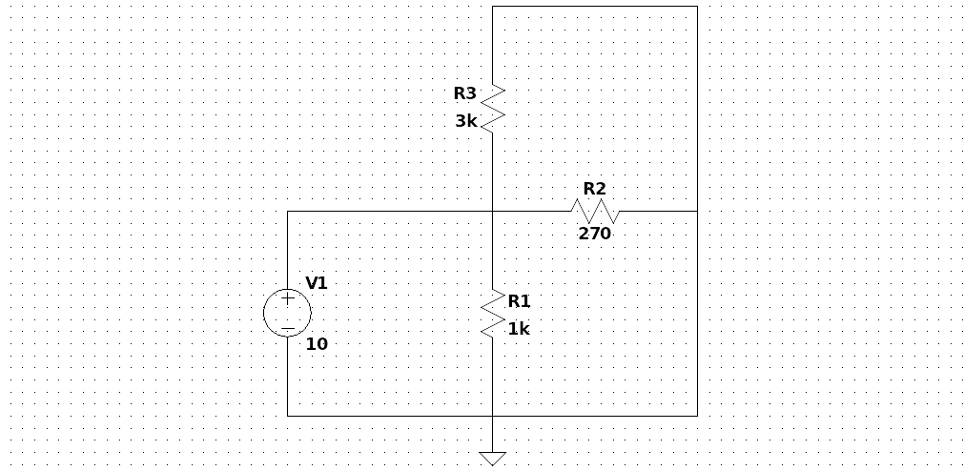Figure 1: Circuit diagram of Experiment 1.

Components and Instruments used:
- A computer: used in the pre-lab to get experiment details from the Moodle
- Resistor kit: contains the resistors to create circuits in the breadboard
- Tektronix PS280 power supply: voltage source
- Fluke multimeter: used to get measurements such as potential difference, current, etc.
- Breadboard: used to create circuits and connect wires to find values

Procedure:
- Create the circuit shown in Figure 1 on breadboard using the shown resistor values.
- Connect the power supply and set it to the 10V of DC voltage.
- Set the multimeter to voltage measurement mode and for each resistor, connect the multimeter as parallel to the resistors and measure the voltage drops.
- Set the multimeter to current measurement mode and for each resistor, connect the multimeter as series before or after to the resistor that you want to measure the current passing through.

Results
RESULTS WITHOUT UNITS WILL NOT BE GRADED!

Table 1: Voltage measurements.
VARIABLE | CALCULATED | MEASURED | ERROR%
V_{R1} | 10V
V_{R2} | 10V
V_{R3} | 10V

Table 2: Current measurements.
VARIABLE | CALCULATED | MEASURED | ERROR%
I_{R1} | 10mA
I_{R2} | 37mA
I_{R3} | 3.32mA

Experiment 2
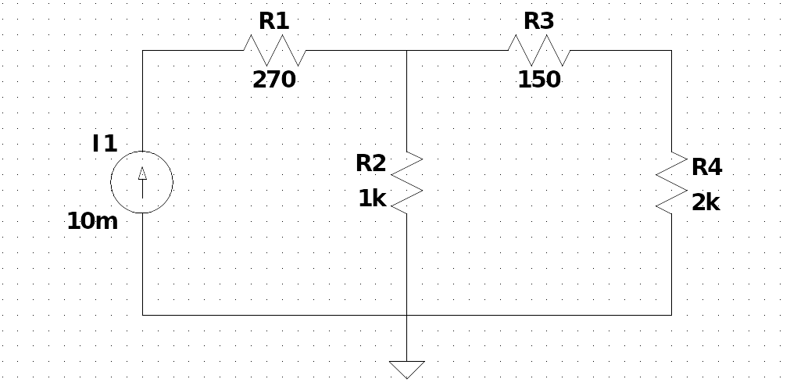Figure 2: Circuit diagram of Experiment 2.

Components and Instruments used:
- A computer: used in the pre-lab to get experiment details from the Moodle
- Resistor kit: contains the resistors to create circuits in the breadboard
- Tektronix PS280 power supply: current source
- Fluke multimeter: used to get measurements such as potential difference, current, etc.
- Breadboard: used to create circuits and connect wires to find values

Procedure:
- Create the circuit shown in Figure 2 on breadboard using the shown resistor values.
- Connect the power supply in constant current mode and set the current to 10mA.
- Set the multimeter to voltage measurement mode and for each resistor, connect the multimeter as parallel to the resistors and measure the voltage drops.
- Set the multimeter to current measurement mode and for each resistor, connect the multimeter as series before or after to the resistor that you want to measure the current passing through.
- Repeat the steps 3 and 4 for 30mA of current source and fill the Table 5 and Table 6.

Results
Table 3: Voltage measurements for iteration 1.
VARIABLE | CALCULATED | MEASURED | ERROR%
V_{R1}
V_{R2}
V_{R3}
V_{R4}

Table 4: Current measurements for iteration 1.
VARIABLE | CALCULATED | MEASURED | ERROR%
I_{R1}
I_{R2}
I_{R3}
I_{R4}

Table 5: Voltage measurements for iteration 2.
VARIABLE | CALCULATED | MEASURED | ERROR%
V_{R1} | 8.10V
V_{R2} | 20.48V
V_{R3} | 1.42V
V_{R4} | 19.05V

Table 6: Current measurements for iteration 2.
VARIABLE | CALCULATED | MEASURED | ERROR%
I_{R1}
I_{R2}
I_{R3}
I_{R4}

